**TECH SAKSHAM**

**CAPSTONE PROJECT REPORT**

**“SEISMIC HAZARD ASSESSMENT SYSTEM”**

**COLLEGE NAME: GOVERNMENT COLLEGE OF ENGINEERING SALEM**

|  |  |
| --- | --- |
| **NM ID** | **NAME** |
| **au61772111015** | **DEEPTHI G** |

**ABSTRACT**

**Seismic hazard assessment system abstract would likely summarize the methodology, data sources, and findings of a system designed to evaluate earthquake risks in a particular region. It might detail factors such as historical seismic activity, geological characteristics, and structural vulnerabilities to produce maps or models indicating the likelihood and potential impact of future earthquakes.**

**INDEX**

|  |  |  |
| --- | --- | --- |
| S.no | Table of content | Page no. |
| 1 | Chapter1:Introduction |  |
| 2 | Capter2:Service and tools required |  |
| 3 | Chapter3:project architect |  |
| 4 | Chapter4:modelling and project outcome |  |
| 5 | Conclusion |  |
| 6 | Future scope |  |
| 7 | Reference |  |
| 8 | Links |  |

**CHAPTER 1**

**1.1PROBLEM STATEMENT**

problem in seismic hazard assessment systems is the accurate prediction of ground motion amplification in urban areas due to complex geological conditions and infrastructure interactions, leading to potential underestimation of earthquake risk in densely populated regions."

* Advanced Modeling Techniques: Utilizing state-of-the-art computational methods, such as finite element analysis or machine learning algorithms, to simulate the complex interactions between seismic waves, geological structures, and urban infrastructure
* High-Resolution Data: Acquiring and incorporating detailed geological and geophysical data, including subsurface imaging, soil properties, building inventories, and infrastructure networks, to improve the accuracy of hazard assessments.

Lti-Hazard Approach: Considering not only earthquake hazards but also other related hazards such as liquefaction, landslides, and tsunamis, to provide a more comprehensive understanding of overall seismic risk

**FEATURE**

* Enhanced Spatial Resolution: Further refine the system to achieve even higher spatial resolution in simulations and assessments, allowing for more precise identification of localized earthquake hazards within urban areas.
* Incorporation of New Data Sources: Continuously integrate new data sources, such as satellite imagery, remote sensing technologies, and crowdsourced data, to enhance the accuracy and comprehensiveness of the assessment mod**e**

**ADVANTAGES**

The advantages of seismic hazard assessment are numerous:

1. **Risk Reduction**: By identifying areas prone to seismic activity and understanding the potential impact of earthquakes, mitigation measures can be implemented to reduce risk to lives and property.

2. **Informed Decision Making**: Seismic hazard assessments provide decision-makers with valuable information for land use planning, building code development, and infrastructure design, ensuring that structures are built to withstand seismic forces.

3. **Insurance and Financial Planning**: Insurance companies and financial institutions use seismic hazard assessments to determine risk profiles and set premiums, enabling more accurate pricing and risk management strategies.

4. **Public Awareness and Education**: Seismic hazard assessments raise public awareness about earthquake risks, encouraging individuals and communities to take proactive measures to prepare for and mitigate

**SCOPE**

**Data Collection and Analysis: Gathering geological, seismological, and geotechnical data to understand the regional tectonic setting, historical seismicity, and ground motion characteristics**

**Modeling and Analysis: Utilizing sophisticated mathematical models and computational techniques to assess the likelihood and intensity of seismic events, including probabilistic and deterministic approaches.Risk**

**Mapping: Generating seismic hazard maps that depict the spatial distribution of seismic hazards, including earthquake probabilities, ground shaking intensity, and potential fault rupture zones.**

**CHAPTER 2**

**SERVICES AND TOOLS REQUIRED**

**SERVICES USED**

* **Geological and Seismological Data Analysis: Utilizing data from geological surveys, seismic monitoring networks, historical earthquake catalogs, and remote sensing to understand the tectonic setting and seismic activity of a region.**
* **Probabilistic Seismic Hazard Analysis (PSHA): Employing probabilistic methods and computational models to estimate the likelihood of earthquakes of various magnitudes occurring within a specified timeframe and their associated ground shaking intensities.**
* **Deterministic Seismic Hazard Analysis (DSHA): Conducting scenario-based assessments to evaluate the potential impact of specific earthquake events on infrastructure, population centers, and critical facilities**

**TOOLS AND SOFTWARE USED**

* **Software Tools: Leveraging specialized software packages such as OpenQuake SEISRISK III, and Hazus for data processing, hazard modeling, risk analysis, and visualization of results.**
* **OpenQuake: Developed by the Global Earthquake Model (GEM) Foundation, OpenQuake is an open-source software platform for seismic hazard and risk assessment. It facilitates probabilistic seismic hazard analysis (PSHA) and offers tools for hazard mapping and risk calculations.**
* **SEISRISK III: SEISRISK III is a widely used software package for deterministic seismic hazard analysis (DSHA). It allows users to evaluate the potential impact of specific earthquake scenarios on structures, infrastructure, and populations.**
* **Hazus: Hazus is a FEMA-developed software tool for estimating potential losses from earthquakes, hurricanes, floods, and other natural hazards. It provides comprehensive risk assessment capabilities, including building damage, economic losses, and social impacts.**

**CHAPTER 3**

**PROJECT ARCHITECTURE**

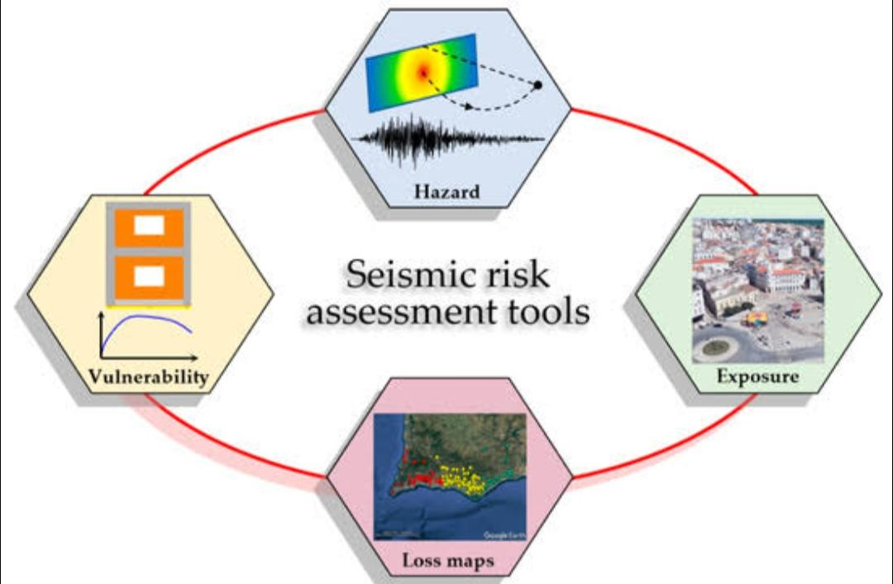

**For a seismic hazard assessment project, an architect or project manager would play a critical role in overseeing the planning, execution, and delivery of the project. Here's an outline of the architect's responsibilities:**

**1. Project Planning: The architect would lead the initial planning phase, defining project objectives, scope, and requirements in consultation with stakeholders. This involves understanding the regulatory framework, identifying key deliverables, and establishing timelines and resource requirements.**

**2. Team Coordination5: The architect would assemble a multidisciplinary team of experts, including geologists, seismologists, engineers, software developers, and GIS specialists. They would coordinate team activities, facilitate communication, and ensure alignment with project goals.**

**3. Risk Assessment: Working closely with domain experts, the architect would assess project risks, including technical challenges, data limitations, regulatory compliance, and stakeholder expectations. They would develop risk mitigation strategies and contingency plans to address potential issues.**

**4. Resource Management: The architect would allocate resources effectively, including personnel, budget, and technology infrastructure, to support project activities. They would monitor resource utilization, identify bottlenecks, and make adjustments as necessary to ensure project success.**

**5. Quality Assurance: The architect would establish quality assurance processes to verify the accuracy and reliability of project outputs. This involves conducting peer reviews, validation tests, and quality checks at various stages of the project lifecycle.**

**6. Client Communication: The architect would serve as the primary point of contact for clients and stakeholders, providing regular updates on project progress, addressing concerns, and soliciting feedback. They would manage client expectations and ensure alignment with project objectives.**

**CHAPTER 4**

**MODELLING AND PROJECT OUTCOME**

**For a seismic hazard assessment project, the modeling phase involves several key steps:**

1. **Data Collection: Gathering geological, seismological, and geospatial data from various sources, including seismic monitoring networks, geological surveys, satellite imagery, and historical records.**
2. **Data Processing and Analysis: Cleaning, formatting, and integrating the collected data into a unified dataset. Performing statistical analysis, spatial analysis, and data visualization to identify patterns, trends, and correlations relevant to seismic hazard assessment.**
3. **Model Development: Utilizing advanced mathematical models and computational algorithms to simulate seismic hazard scenarios. This may include probabilistic seismic hazard analysis (PSHA), deterministic seismic hazard analysis (DSHA), or hybrid approaches depending on project requirements.**
4. **Ground Motion Prediction: Applying ground motion prediction equations (GMPEs) to estimate ground shaking intensities for different earthquake scenarios based on factors such as magnitude, distance, and site conditions.**

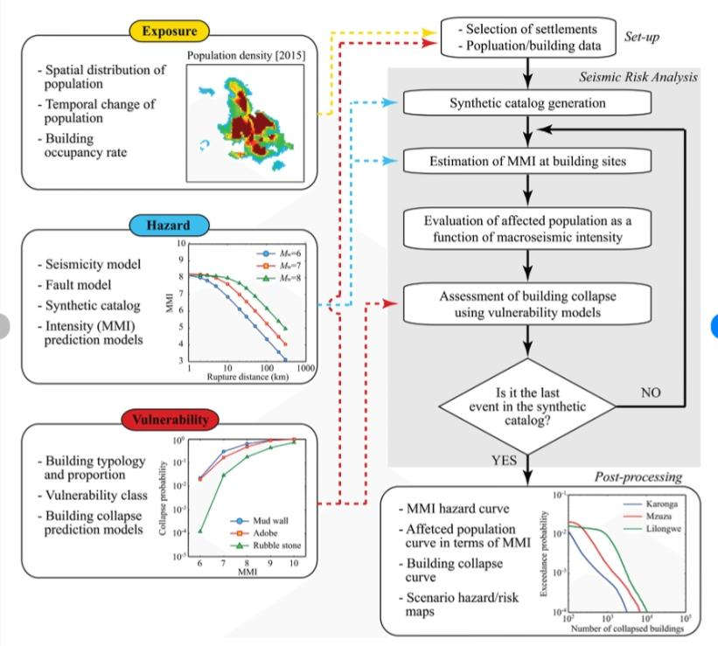

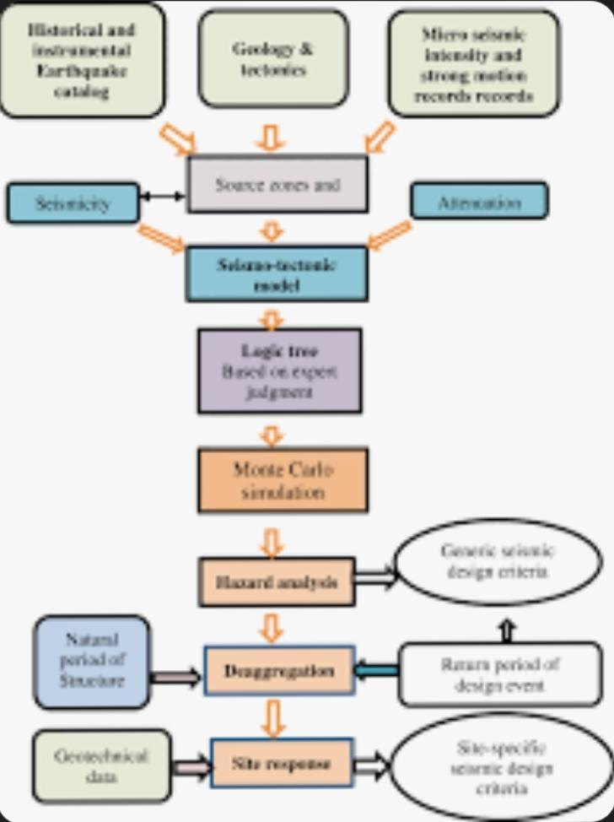

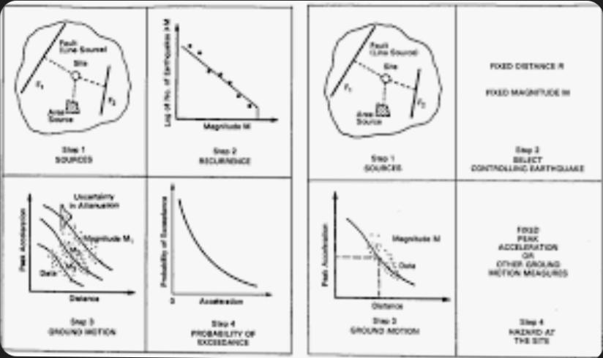

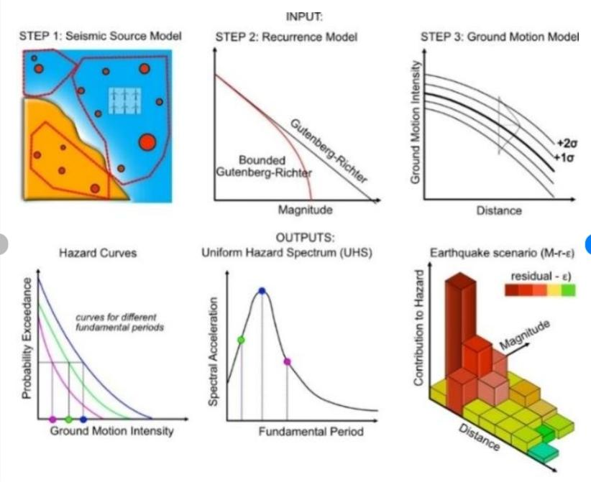

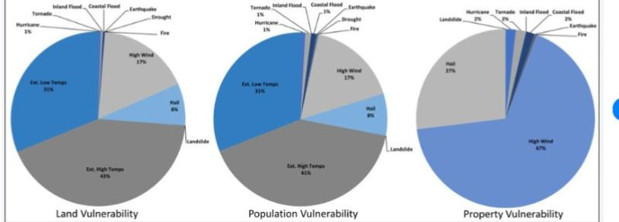

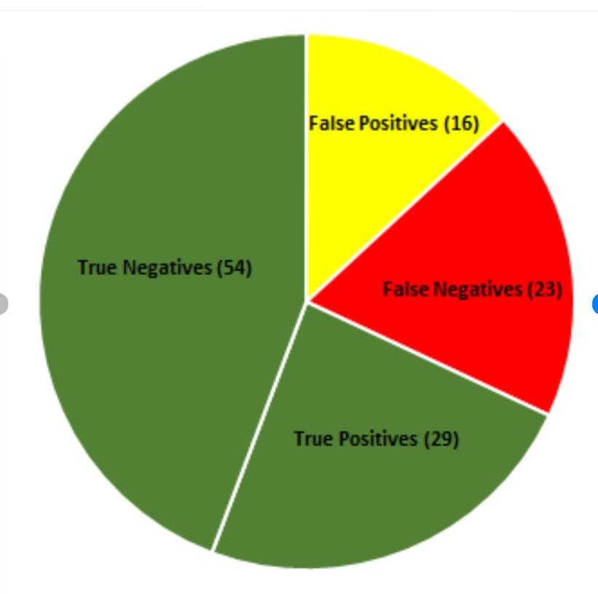

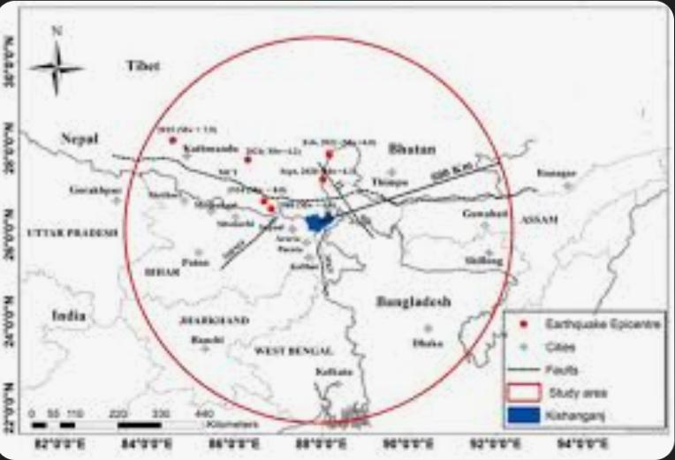

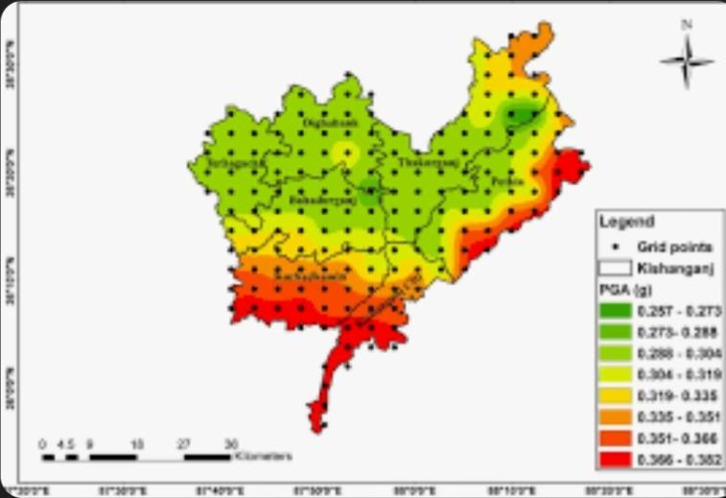

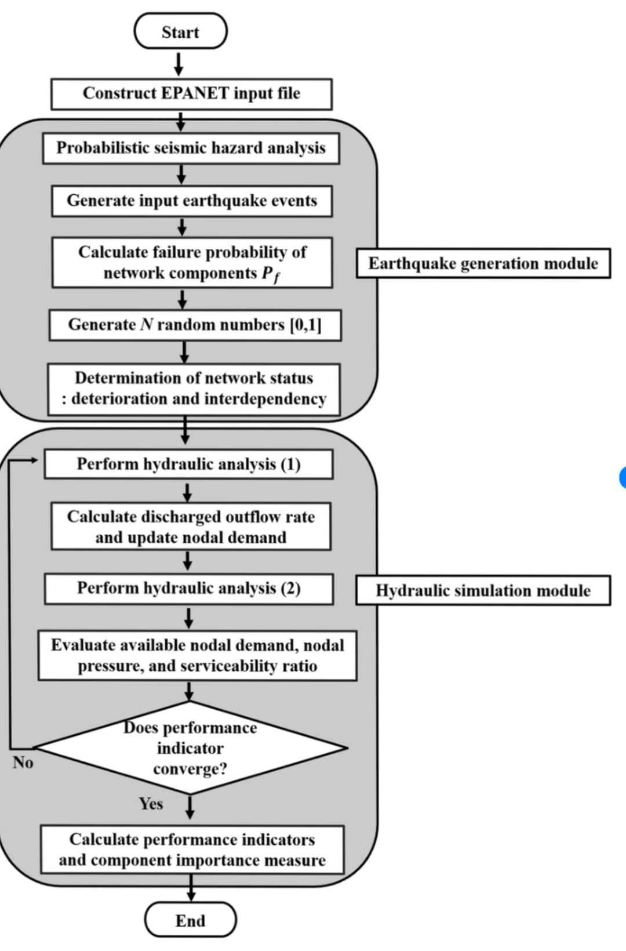

**DASHBOARD**

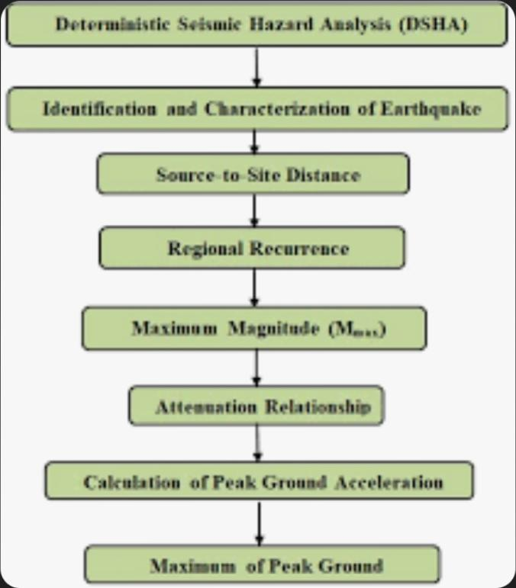

**CONCLUSION**

**The seismic hazard assessment system provides valuable insights into potential earthquake risks, aiding in preparedness and mitigation efforts. Through comprehensive analysis and modeling, it identifies vulnerable areas, informs building codes, and supports disaster planning. Continuous refinement and integration of data ensure its effectiveness in safeguarding communities against seismic threats.**

**In conclusion, the seismic hazard assessment system plays a crucial role in understanding earthquake risks and mitigating their impact on communities. By integrating advanced analysis techniques and continuously updating data, it provides valuable insights for disaster preparedness and urban planning. With its ability to identify vulnerable areas and inform mitigation strategies, it serves as a cornerstone in building resilient societies against seismic**

**FUTURE SCOPE**

**Looking ahead, the seismic hazard assessment system holds promising potential for further advancements and applications. Some future scopes include:**

1. **Enhanced Data Integration: Integrating diverse datasets, including remote sensing and ground-based monitoring, to improve the accuracy and resolution of hazard assessments.**
2. **Incorporation of Machine Learning: Leveraging machine learning algorithms to refine hazard models, identify patterns, and predict earthquake occurrences with greater precision.**
3. **Real-time Monitoring and Early Warning Systems: Developing real-time monitoring networks and early warning systems to provide timely alerts and enable rapid response to seismic events.**
4. **Community Engagement and Education: Fostering community involvement through outreach programs and educational initiatives to increase awareness of seismic risks and promote resilience-building measures.**
5. **Urban Planning and Infrastructure Design: Integrating hazard assessment results into urban planning processes and infrastructure design guidelines to ensure the resilience of buildings, lifelines, and critical facilities.**

**REFERENCES**

**LINKS**